RECOMMENDATIONS FOR THE PARENTS OF A CHILD
WITH CRANIOSYNOSTOSIS

Lucy Gooding Pediatric Neurosurgery Center
University of Florida HSC Jacksonville
and
Wolfson Children's Hospital
Jacksonville, Florida
U.S.A.

www.childneurosurgery.com

Sponsored in part by:

The Foundation for Pediatric and Laser Neurosurgery, Inc.

www.fpln.org
PREFACE

If your child has been diagnosed as having a deformity of the head, which will require surgical correction, then a significant amount of stress has been placed on you over the cause of the problem, the treatment, and what will happen to your child and the future of your family.
The purpose of this handout is to assist you with the understanding of the problem, the treatment, and the end result, by looking at the various forms of craniosynostosis, the evaluation, diagnostic procedures, and principles of correcting the disorder. The most common questions raised by parents have also been addressed.

INTRODUCTION

The term “craniosynostosis” refers to the bones of the top of the head, the “cranium.” In this disease, the bones of the top of the head are involved. (Figure 1)

Figure 1. NORMAL HEAD: The head is formed by the calvarium (cranium) and the face.
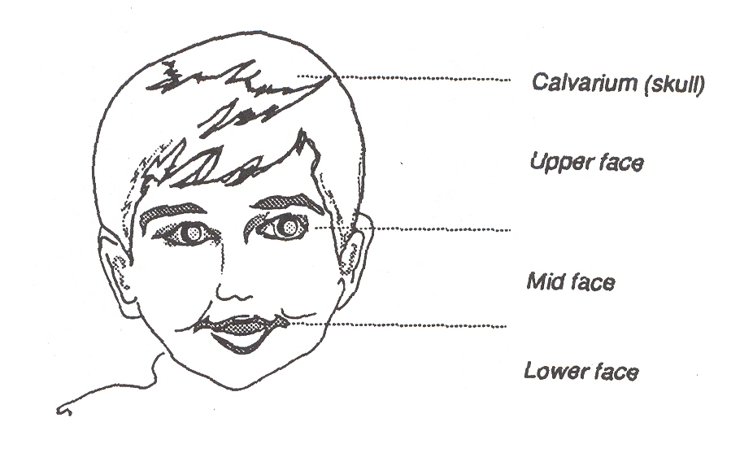

Because of the involvement of the covering of the brain, the potential for limitation of the brain growth, the possibility of associated hydrocephalus and the age of your child, your primary care physician has asked you to see specialists for definitive diagnosis and treatment and a neurosurgeon who specializes in children.

NORMAL SKULL ANATOMY

Five sets of bone make up the cranium (figure 2): Frontal bone (one)
Temporal bones
Parietal bones
Occipital bone (one)

Figure 2. Illustration of the cranial bones. Bones separated by membranous seams until
sutures gradually close.
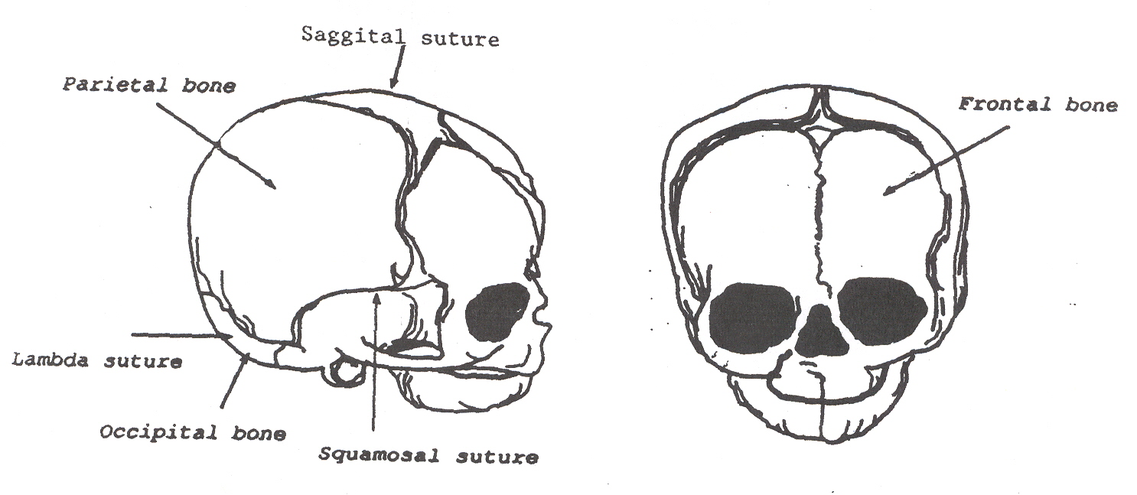

Sagittal suture

Joining these bone plates together are points of union called “sutures.” Each one carries a different name. For instance, the connection between the single frontal bone and the adjacent parietal bone is called the coronal suture.

Craniosynostosis results when one or more of these sutures close (“ossify” or “synostose”) too early during the infant’s development. This creates is a limitation in brain growth, as well as a consequent deformity of the head due to the restricted growth in that area. The majority of craniosynostosis is diagnosed by the examination of the child due to the typical deformity that the closure of the involved suture(s) creates.

DEVELOPMENT OF THE BRAIN

Inside the womb, development of the brain and spinal cord (central nervous system) of the fetus takes place within the first four weeks after conception. Formation of the craniofacial structures around the brain is a very complicated and poorly understood process. Normally a baby is born with sutures that allow the bones to stay separate and permit ready growth of the brain by allowing the bones to spread apart as the brain increases in size, and therefore adapt the calvarium to the needs of the brain. This accounts for the rapid increase in the head circumference in the first few months of life.

The principal sutures in the infant skull are the sagittal, coronal and lambdoid sutures (see Figure 2). There are two major soft areas, the anterior and posterior fontanelles. These “soft” areas are very important in early infancy for the rapid growth of the cranium. The brain growth is extremely rapid in the first two years of life so that 75% of the total growth of the brain is completed by 18 months of age. Normally in doing this the brain will have tripled in weight and size during this period.
The skull grows in a direction perpendicular to the line of the suture, and normal closure of the suture(s) occurs in a regular and predictable order. Although there are normally wide variations in the age at which the sutures are “hardened” (ossified), the usual pattern is as follows:

Three (3) months of age: the posterior fontanelle closes
Six (6) months of age: the basic union (but not closure) of sutures
Twenty (20) months of age: the anterior fontanelle is closed
Adolescence: solidly formed skull

CRANIOSYNOSTOSIS

Craniosynostosis is the term employed to define premature closure of sutures. At times it is used interchangeably with the term “craniostenosis;” however, for some this term means a premature closure of all sutures of the calvarium.

From what has been said previously on the normal pattern of brain development, it is now easier to imagine that fusion of these sutures in the first months of life can restrict brain growth, which could lead to varying forms of brain damage. This will be determined by how many sutures are involved, how long the closure has been going on for, and the success or failure of the other sutures to compensate the expansion.
Craniosynostosis may represent a single primary defect in an otherwise normal child, or it may be on feature of a syndrome involving other malformations. This may then be of subsequent genetical importance.

CLINICAL FORMS OF CRANIOSYNOSTOSIS

There are many forms of craniosynostosis, some well described and some poorly understood and incompletely listed in the medical literature. Most of these have variations not only in the degree of craniosynostosis, but also in the magnitude of faciostenosis, involvement of orbits, etc. However, several have together with these deformities of other parts of the body, particularly the hands and feet. The fingers and toes may be fused together (syndactily), or may be different in length and size to the normal. The constellation of these findings allows the physician to prognose how that particular child will develop in some cases, and it will permit the identification of the genetical importance of this disease to that family and child.

Sagittal Synostosis

Sagittal suture synostosis or “scaphocephaly” is the most common form of craniosynostosis. It occurs in 1 out of 1000 deliveries and presents at random. It is rarely fatal; therefore it does not carry genetical implications. It is felt that scaphocephaly is caused by restriction of the growth of the head during development in the womb in such a way that the transverse axis of the skull is affected. The head is a long shape (“football shape”), usually with a prominent brow. (Figure 3)

Unilateral Coronal Synostosis

Unilateral suture synostosis is a result of a combination of closure of sutures, the coronal suture and some of the underlying sutures at the base of the forehead (frontoethmoidal or frontosphenoidal). The consequence is that the forehead in the involved side cannot grow and remains flattened or “frontal plagiocephaly,” and the orbit on that side may be distorted. It is felt that unilateral suture synostosis is caused by a restriction of growth during the late stages of pregnancy, with pressure creating an early “hardening” of the sutures. (Figure 3)

Bicoronal Synostosis

Bicoronal synostosis or “brachycephaly” is a result from both coronal sutures closing early, which results in a broad, large, flat forehead. This particular form of craniosynostosis is most commonly seen as a disorder with more serious genetical implications for the family. It occurs more frequently as a part of a premature closure of the sutures of the face, and this combination is called “craniofacial dysostosis” because of the association of the closure of the sutures of the cranium as well as those of the midface. (Figure 3) For more information on this condition, please refer to the Craniofacial Dysostosis Handout.

Lambda Synostosis

Lambda synostosis or “occipital plagiocephaly” is a rare condition in which there is premature closure of the suture that is between the occipital bone on the back of the head and the parietal bone. It produces a flattening in the back of the head of the side involved. This condition is commonly confused with the flattening of the back of the head that occurs when the baby sleeps in one position and is also placed in this same position during awake hours. It may be favored by limitation of movement of the neck due to minor injury to the neck muscles during the mechanics of delivery (congenital torticollis). This condition requires surgery when it is very severe; however, most of these improve with better positioning of the baby and with stretching exercises to the affected neck muscles.

Figure 3. Illustration of the clinical forms of synostosis.
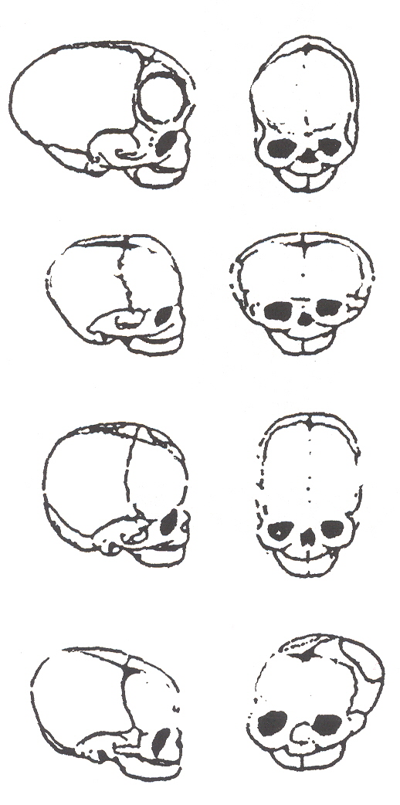 | Scaphocephaly: Premature closure of the sagittal suture, resulting in restricted lateral growth.  Acrocephaly: Premature closure of both coronal sutures, resulting in excessive lateral growth.  Oxycephaly or Turricephaly: Premature closure of all coronal and lambda sutures, resulting in accelerated upward growth and small head circumference.  Plagiocephaly: Unilateral premature closure of a coronal suture, resulting in asymmetric growth.

DIAGNOSIS

The more severe forms of craniosynostosis are diagnosed readily at birth, whereas they might be mild enough not to cause suspicion on examination. The diagnosis is made in most of the babies just by examining the child for the signs that were previously discussed.

PLAIN RADIOGRAPHS (X-RAYS)

Plain radiographs of the child’s head (skull x-rays) will reveal bone bridging the defect of the suture, which normally is not present. The accompanying deformity of the cranium and face will allow the physician to see the disproportion of these structures and diagnose the craniofacial dysostosis radiologically.

THE GENETICIST/DYSMORPHOLOGIST, YOUR CHILD, AND YOUR FAMILY

The geneticist/dysmorphologist is a pediatric specialist in birth defects. If not already done, we often request this pediatrician who specializes in deformations and genetics (dysmorphology) to see your child for consultation. This physician will examine your child and evaluate your family history in an attempt to determine the cause of the craniofacial malformation. Not only is this important for your child, but then according to the type of syndrome, this physician will inform you of the potential risk factors of having other children with craniofacial deformities. The risk in some cases of having another child with this may be as high as 50% or as low as zero.

To that end the geneticist may order some specific tests, such as chromosomal analysis if felt needed, to confirm or deny some malformation syndrome of genetical importance.

SURGICAL CONSIDERATIONS

Due to mechanical phenomenon created by the ossification of the sutures, the types of craniofacial dysostosis previously discussed can only be corrected by a combination of surgeries and orthodontic work. Therefore we will discuss the aspects of operative procedures.

SURGERY FOR CRANIOSYNOSTOSIS

The baby does not require major preoperative preparation. Instructions for when to stop feeding the child prior to anesthesia will be given, according to the age of the child. This is done to prevent problems of vomiting and the stomach contents going the wrong way at the time of administration of anesthesia.

We may require a cleaning of the head with an antiseptic shampoo be done upon admission to the hospital to reduce the risk of infection at surgery. Blood samples will be taken to check the blood count, and other studies to ensure the baby has no problems of clotting or related that may complicate the surgery.

Blood will be requested in most situations for transfusion during or after surgery, or both. The infants do not tolerate blood loss, since their bodies to do not have the basic reflexes to adjust for blood loss at this age. Therefore, transfusions are necessary. If not, a life-threatening situation may arise from a serious drop in blood pressure. Our office will give you instructions as to how the blood bank will help you obtain the correct blood for your baby. Current technology has blood testing performed to such a degree that risks of transfusions are extremely small. For additional information, our office will provide you with the literature that provides you with the instructions for this.

The pediatric anesthesiologist will meet you prior to the operation in the preoperative area and discuss with you the various aspects of the anesthesia and recovery.

OPERATION

Prior to operation we will discuss the procedure with you since no set operations are performed on all children, but we must adjust the operative procedure to the specific needs of your child. The basic principles that one can state is that the operative incision(s) are placed behind the child’s hairline so that when the hair grows back, no incisions will be seen. No incisions are placed on the face.

The type of operation performed is a “reconstructive” one and not only a “release” of the suture(s) that is involved is performed, but the “remodeling” of the deformity is done at the same operation. The primary objective is to permit brain growth.

Bandages are placed at the end of the operation and left on for several days to place some degree of external pressure on the scalp to reduce the amount of postoperative bleeding and help correct the deformity.

POSTOPERATIVE CONCERNS

Since the surgery is extensive, most parents expect that the child will have a lot of pain. Fortunately, the region that was operated on does not have movements, like the wall of the abdomen does with respiration, and therefore has less tenderness. Irritability is most commonly seen for 24-48 hours after surgery, and responds very well to holding and cuddling by the parents. Pain medications are given, but not in excess so that the baby may start to feed again shortly after surgery. We recommend that feedings (breast milk or formula) be initially given in small amounts frequently, rather than a large amount, since vomiting maybe produced by stretching the stomach too quickly.

Bandages may be present around the eyes and upper face. Not uncommonly a lot of swelling of the EYELIDS may be present, but this does not create problems for the eyeballs. Your child may be very fussy because of the inability to see through swollen eyelids. Reassurance is needed. The swelling goes down and disappears a few days after surgery, on its own, and no special treatments are needed.

According to the extent of the surgery that is performed, various types of intravenous and related lines may be present. Your child may have a catheter in the bladder for the first days after surgery, as well as a catheter in an artery. These are all aspects of critical intensive care, to better monitor your child after surgery. As the child recovers these various devices are steadily easily removed as they are deemed no longer needed. The critical care nurse will help you understand the role of these devices, and respond to your concerns.

The hospital stay is for a few days, then bandages are removed and wound care instructions are given to the parents, and suture will be removed from the scalp approximately two weeks after surgery. Other than once daily care of the wound, no other special requirements will be needed when the baby is home.

CONCLUSION

Current early diagnosis has permitted these children to be promptly referred to the pediatric neurosurgeon for evaluation and correction. The principles of reconstructive cranial surgery have evolved to such a degree that your child will receive the benefit of modern treatment. Release of the brain and adequate growth of this vital structure will be attained, and the underlying deformity can be corrected to avoid potentially serious psychological effects in early childhood, school years and adolescence.

HEJ/js
Reviewed/Revised 10/10/2007

